CS561 HW 5

All queries on this homework relate to the multi-company database in SQL Chapter

Translate each of the following queries into extended Relational Algebra

1. (Use COUNT to do this one) Find every person who is not skilled in the manufacture of any product manufactured by company “111-22-3333

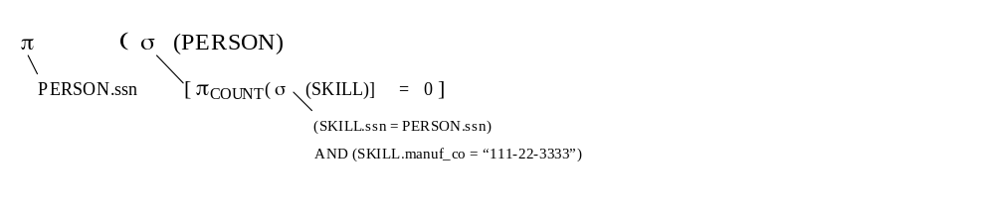
2. (Use COUNT to do this one) Find every person who is skilled in the manufacture of every product manufactured by 111-22-3333.
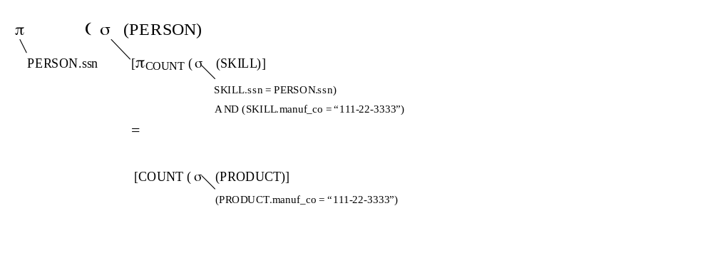
3. Find every person who is skilled at the manufacture of more products manufactured by company 111-22-3333 than the average number of the company’s products at which employees of the company are skilled

π _{PERSON.ssn} σ (PERSON)
[(number of products manufactured by 111-22-3333 at which PERSON is skilled)
>
(average number of products manufactured by 111-22-3333 at which employees of 111-22-3333 are skilled)]
WHICH IS:
π _{PERSON.ssn} σ (PERSON)
[(number of products manufactured by 111-22-3333 at which PERSON is skilled)
>
[(total number of skills of employees of 111-22-3333 at products manufactured by 111-22-3333)
/
(number of employees of 111-22-3333)] ]

number of products manufactured by 111-22-3333 at which PERSON is skilled can be written as:
π _{COUNT(*)} σ (PRODUCT X SKILL)
(PRODUCT.prod_id = SKILL.prod_id)
AND (PRODUCT.manuf_co = SKILL.manuf_co)
AND (PRODUCT.manuf_co = 111-22-3333)
AND (SKILL.ssn = PERSON.ss
total number of skills of employees of 111-22-3333 at products manufactured by 111-22-3333 can be written as:
π _{COUNT(*)} σ (WORKS_FOR X SKILL)
(WORKS_FOR.co_id = SKILL.manuf_co)
AND (WORKS_FOR.ssn = SKILL.ssn)
AND (SKILL.manuf_co = 111-22-3333)
number of employees of 111-22-3333 can be written as:
π _{COUNT(*)} σ (WORKS_FOR)
(WORKS_FOR.co_id = 111-22-3333)

4. Find every company whose CEO is skilled at the manufacture of at least one product manufactured by a company of which s/he is not the CEO.

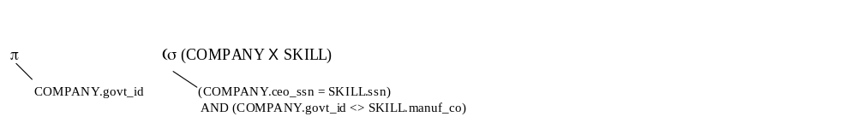Translate each of the following queries into SQL, using only SQL constructs that have been discussed thus far.

5. Find every company whose CEO is skilled at the manufacture of at least one product manufactured by a company of which s/he is not the CEO.

This one can be done with COUNT, and you got full credit for doing it correctly with COUNT. The solution below doesn’t use COUNT, and is likely to be more efficient than a version that uses COUNT. (Such issues are considered in CS562.)

SELECT COMPANY.govt_id
FROM COMPANY, SKILL
WHERE (COMPANY.ceo_ssn = SKILL.ssn)
AND (COMPANY.govt_id <> SKILL.manuf_co)

6. Find every person who is not skilled in the manufacture of any product manufactured by a company s/he works for.

Strategy:
SELECT PERSON.ssn
FROM PERSON
WHERE (COUNT(skills person has in the manufacture of products manufactured by companies s/he works for) = 0 )

SELECT PERSON.ssn
FROM PERSON
WHERE ((SELECT COUNT(*)
FROM SKILL, WORKS_FOR
WHERE (SKILL.ssn = PERSON.ssn)
AND (WORKS_FOR.ssn = PERSON.ssn
AND (SKILL.manuf_co = WORKS_FOR.co_id))
= 0 )

7. Find every company all of whose divisions are headquartered in the same (any) city.

Strategy:
SELECT COMPANY.govt_id
FROM COMPANY
WHERE (COUNT(distinct division headquarter cities of divisions of company) = 1)

SELECT COMPANY.govt_id
FROM COMPANY
WHERE ((SELECT COUNT(DISTINCT DIVISION.div_hq)
FROM DIVISION
WHERE (DIVISION.co_id = COMPANY.govt_id)) = 1)

8. Find every person who works for at least five different companies.

SELECT PERSON.ssn
FROM PERSON
WHERE (((SELECT COUNT(DISTINCT WORKS_FOR.co_id)
FROM WORKS_FOR
WHERE (WORKS_FOR.ssn = PERSON.ssn))) >= 5)

9. Find every person who is either the CEO of a company that has a division headquartered in Boston or works for a company that has a division headquartered in Boston.

(SELECT COMPANY.ceo_ssn
FROM COMPANY, DIVISION
WHERE (COMPANY.govt_id = DIVISION.co_id)
AND (DIVISION.div_hq = “Boston”))

UNION

(SELECT WORKS_FOR.ssn
FROM WORKS_FOR, DIVISION
WHERE (WORKS_FOR.co_id = DIVISION.co_id)
(DIVISION.div_hq = “Boston”))

10. Find every company that has a division headquartered in Philadelphia, which division manufactures a product at whose manufacture the person with SSN 222-33-4444 is skilled.

SELECT DIVISION.co_id
FROM DIVISION, PRODUCT, SKILL
WHERE (DIVISION.co_id = PRODUCT.manuf_co)
AND (PRODUCT.manuf_co = SKILL.manuf_co)
AND (PRODUCT.prod_id = SKILL.prod_id)
AND (PRODUCT.manuf_div = DIVISION.div_name)
AND (DIVISION.div_hq = “Philadelphia”)
AND (SKILL.ssn = “222-33-4444”)

